Farm Verse Precision Agriculture Management Platform
MILESTONE 2
LIST OF REQUIREMENT:
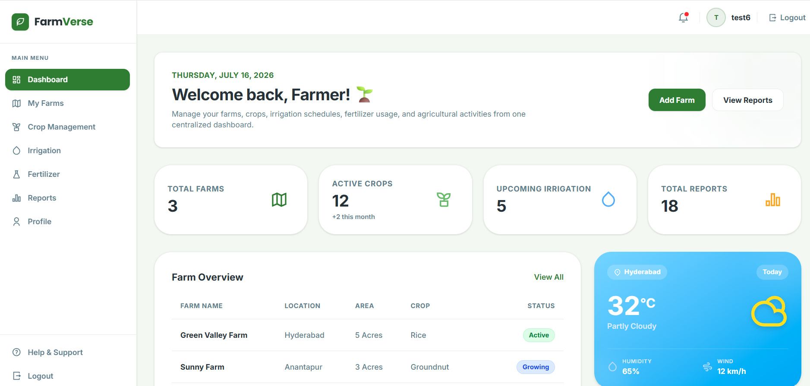
1. Add Farm
Purpose : Allows an authenticated farmer to add a new farm.
Endpoint
POST /api/farms/addfarms
Request Payload:
{
"farmName": "Green Valley Farm",
"farmType": "Organic",
"location": "Coimbatore, Tamil Nadu",
"totalArea": 10.5,
"soilType": "Loamy",
"waterSource": "Borewell",
"description": "Organic vegetable cultivation"
}
Response Payload (Success)
{
"status": "success",
"statusCode": 201,
"message": "Farm added successfully."
}
Response Payload (Validation Error)
{
"status": "error",
"statusCode": 400,
"message": "Farm name is required."
}
Response Payload (Unauthorized)
{
"status": "error",
"statusCode": 401,
"message": "Unauthorized. Please login."
}
2. Dashboard Summary
Purpose
Retrieves the dashboard statistics for the currently logged-in farmer, including total farms, active crops, upcoming irrigation schedules, and total reports.
Endpoint
GET /api/dashboard/getusersummary
Authorization
Bearer Token (JWT Required)
Request Payload
None
Response Payload (Success)
{
"status": "success",
"statusCode": 200,
"data": {
"totalFarms": 3,
"activeCrops": 12,
"upcomingIrrigation": 5,
"totalReports": 18
}
}
Response Payload (Unauthorized)
{
"status": "error",
"statusCode": 401,
"message": "Unauthorized. Please login."
}
3. Farm Overview
Purpose
Retrieves all farms belonging to the currently logged-in farmer and displays them in the Farm Overview section.
Endpoint
GET /api/farms/getfarmsdata
Authorization
Bearer Token (JWT Required)
Request Payload
None
Response Payload (Success)
{
"status": "success",
"statusCode": 200,
"data": [
{
"farmId": 1,
"farmName": "Green Valley Farm",
"location": "Hyderabad",
"area": "5 Acres",
"crop": "Rice",
"status": "Active"
},
{
"farmId": 2,
"farmName": "Sunny Farm",
"location": "Anantapur",
"area": "3 Acres",
"crop": "Groundnut",
"status": "Growing"
}
]
}
Response Payload (Unauthorized)
{
"status": "error",
"statusCode": 401,
"message": "Unauthorized. Please login."
}
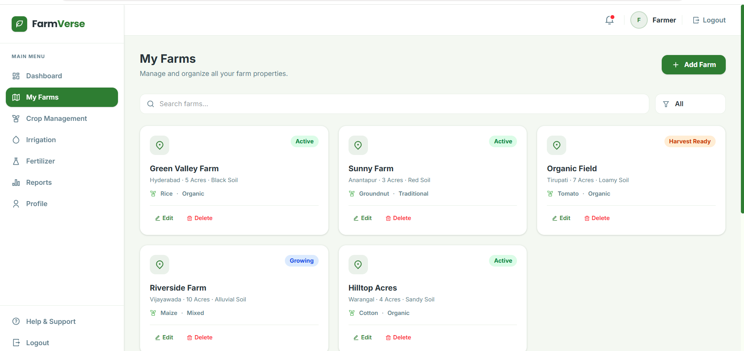
1. Get All Farms
Purpose
Retrieves all farms belonging to the currently logged-in farmer and displays them in My Farms.
Endpoint
GET /api/farms/getallfarms
Authorization
Bearer Token (JWT Required)
Request Payload
None
Response Payload (Success)
{
"status": "success",
"statusCode": 200,
"data": [
{
"farmId": 1,
"farmName": "Green Valley Farm",
"location": "Hyderabad",
"area": 5.5,
"soilType": "Black Soil",
"createdAt": "2026-07-18T18:30:00"
},
{
"farmId": 2,
"farmName": "Sunny Farm",
"location": "Warangal",
"area": 3.2,
"soilType": "Red Soil",
"createdAt": "2026-07-19T09:15:00"
}
]
}
Response Payload (No Farms)
{
"status": "error",
"statusCode": 404,
"message": "No farms found."
}
Response Payload (Unauthorized)
{
"status": "error",
"statusCode": 401,
"message": "Unauthorized. Please login."
}

2. Get Farm By ID
Purpose
Retrieves the details of a specific farm belonging to the logged-in farmer.
Endpoint
GET /api/farms/{farmId}
Authorization
Bearer Token (JWT Required)
Request Payload
None
Response Payload (Success)
{
"status": "success",
"statusCode": 200,
"data": {
"farmId": 1,
"farmName": "Green Valley Farm",
"location": "Hyderabad",
"area": 5.5,
"soilType": "Black Soil",
"createdAt": "2026-07-18T18:30:00"
}
}
Response Payload (Not Found)
{
"status": "error",
"statusCode": 404,
"message": "Farm not found."
}

3. Update Farm
Purpose
Updates the details of a farm owned by the currently logged-in farmer.
Endpoint
PUT /api/farms/updatefarm/{farmId}
Authorization
Bearer Token (JWT Required)
Request Payload
{
"farmName": "Green Valley Farm",
"location": "Hyderabad",
"area": 6.0,
"soilType": "Loamy Soil"
}
Response Payload (Success)
{
"status": "success",
"statusCode": 200,
"message": "Farm updated successfully."
}
Response Payload (Validation Error)
{
"status": "error",
"statusCode": 400,
"message": "Invalid farm details."
}
Response Payload (Not Found)
{
"status": "error",
"statusCode": 404,
"message": "Farm not found."
}
4. Delete Farm
Purpose
Deletes a farm belonging to the currently logged-in farmer.
Endpoint
DELETE /api/farms/deletefarm/{farmId}
Authorization
Bearer Token (JWT Required)
Request Payload
None
Response Payload (Success)
{
"status": "success",
"statusCode": 200,
"message": "Farm deleted successfully."
}
Response Payload (Not Found)
{
"status": "error",
"statusCode": 404,
"message": "Farm not found."
}
Response Payload (Unauthorized)
{
"status": "error",
"statusCode": 401,
"message": "Unauthorized. Please login."
}

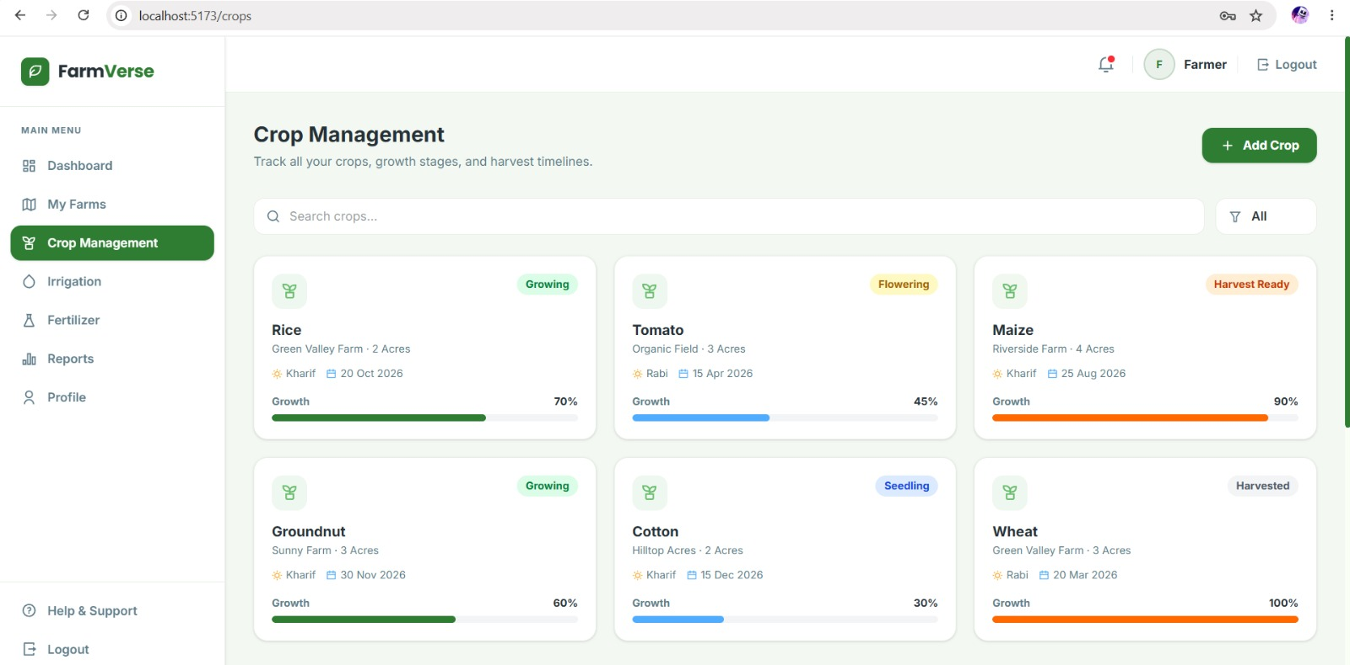
1. Add Crop
Purpose : Allows an authenticated farmer to add a new crop to a selected farm.
Endpoint
POST /api/crops/addcrop
Authorization
Bearer Token (JWT Required)
Request Payload:
{
"farmId":1,
"cropName":"Rice",
"season":"Kharif",
"area":"2 Acres",
"expectedHarvest":"2026-10-20",
"growth":70,
"status":"Growing"
}
Response Payload (Success)
{
"status":"success",
"statusCode":201,
"message":"Crop added successfully."
}
Response Payload (Validation Error)
{
"status":"error",
"statusCode":400,
"message":"Invalid crop details."
}
Response Payload (Unauthorized)
{
"status":"error",
"statusCode":401,
"message":"Unauthorized. Please login."
}
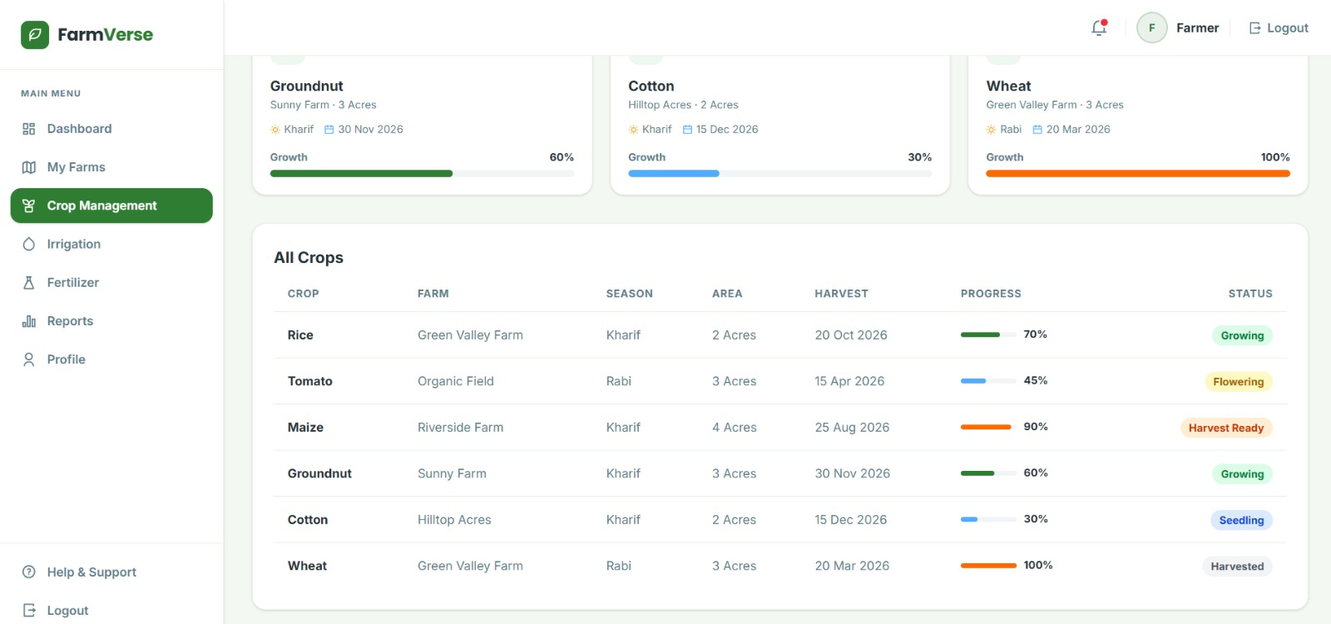

2. Get All Crops
Purpose : Retrieves all crops belonging to the logged-in farmer and displays them in Crop Management.
Endpoint
GET /api/crops/getallcrops
Authorization
Bearer Token (JWT Required)
Request Payload:
None
Response Payload (Success)
{
"status":"success",
"statusCode":200,
"data":[{"cropId":1,"cropName":"Rice","farm":"Green Valley Farm","status":"Growing"}]
}
Response Payload (Validation Error)
{
"status":"error",
"statusCode":400,
"message":"Invalid crop details."
}
Response Payload (Unauthorized)
{
"status":"error",
"statusCode":401,
"message":"Unauthorized. Please login."
}
3. Update Crop
Purpose : Updates crop growth, harvest date and crop status.
Endpoint
PUT /api/crops/update/{cropId}
Authorization
Bearer Token (JWT Required)
Request Payload:
{
"growth":80,
"status":"Flowering"
}
Response Payload (Success)
{
"status":"success",
"statusCode":200,
"message":"Crop updated successfully."
}
Response Payload (Validation Error)
{
"status":"error",
"statusCode":400,
"message":"Invalid crop details."
}
Response Payload (Unauthorized)
{
"status":"error",
"statusCode":401,
"message":"Unauthorized. Please login."
}
4. Delete Crop
Purpose : Deletes a crop record.
Endpoint
DELETE /api/crops/delete/{cropId}
Authorization
Bearer Token (JWT Required)
Request Payload:
Path Variable : cropId
Response Payload (Success)
{
"status":"success",
"statusCode":200,
"message":"Crop deleted successfully."
}
Response Payload (Validation Error)
{
"status":"error",
"statusCode":400,
"message":"Invalid crop details."
}
Response Payload (Unauthorized)
{
"status":"error",
"statusCode":401,
"message":"Unauthorized. Please login."
}
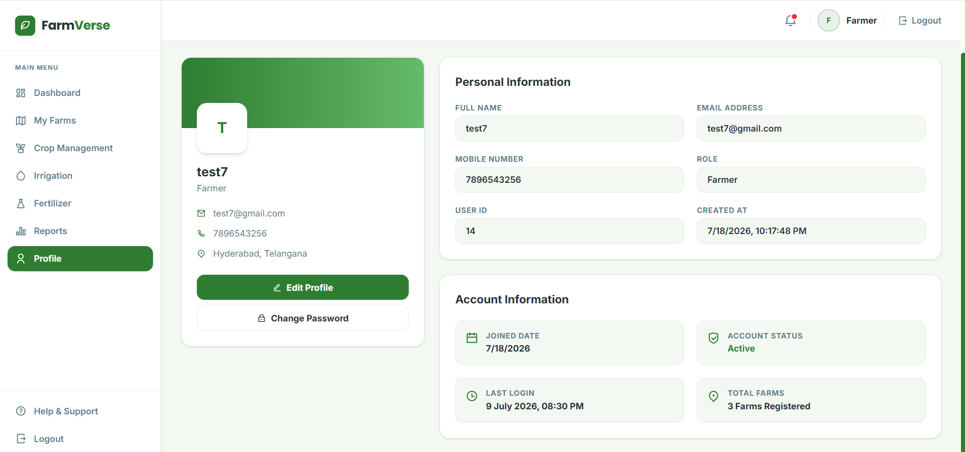
1. Get Profile
Purpose
Retrieves the profile details of the currently logged-in user and displays them on the Profile page.
Endpoint
GET /api/profile
Authorization
Bearer Token (JWT Required)
Request Payload
None
Response Payload (Success)
{
"status": "success",
"statusCode": 200,
"data": {
"userId": 14,
"fullName": "test7",
"email": "test7@gmail.com",
"phone": "7896543256",
"role": "Farmer",
"location": "Hyderabad, Telangana",
"createdAt": "2026-07-18T22:17:48"
}
}
Response Payload (Unauthorized)
{
"status": "error",
"statusCode": 401,
"message": "Unauthorized. Please login."
}

2. Update Profile
Purpose
Updates the logged-in user's profile information.
Endpoint
PUT /api/profile/update
Authorization
Bearer Token (JWT Required)
Request Payload
{
"fullName": "Test Farmer",
"phone": "9876543210",
"location": "Hyderabad, Telangana"
}
Response Payload (Success)
{
"status": "success",
"statusCode": 200,
"message": "Profile updated successfully."
}
Response Payload (Validation Error)
{
"status": "error",
"statusCode": 400,
"message": "Invalid profile details."
}
Response Payload (Unauthorized)
{
"status": "error",
"statusCode": 401,
"message": "Unauthorized. Please login."
}
3. Change Password
Purpose
Allows the logged-in user to change their account password.
Endpoint
PUT /api/profile/change-password
Authorization
Bearer Token (JWT Required)
Request Payload
{
"oldPassword": "old123",
"newPassword": "new123456"
}
Response Payload (Success)
{
"status": "success",
"statusCode": 200,
"message": "Password changed successfully."
}
Response Payload (Validation Error)
{
"status": "error",
"statusCode": 400,
"message": "Old password is incorrect."
}
Response Payload (Unauthorized)
{
"status": "error",
"statusCode": 401,
"message": "Unauthorized. Please login."
}

4. Get Total Farms (Optional)
Purpose
Returns the total number of farms owned by the logged-in user. This endpoint is useful because the Profile page displays "3 Farms Registered".
Endpoint
GET /api/profile/farm-count
Authorization
Bearer Token (JWT Required)
Request Payload
None
Response Payload (Success)
{
"status": "success",
"statusCode": 200,
"data": {
"totalFarms": 3
}
}
Response Payload (Unauthorized)
{
"status": "error",
"statusCode": 401,
"message": "Unauthorized. Please login."
}

